
Semester | T.E. Semester VI– SPCC
Subject | Software Engineering
Subject Professor In-charge | Prof. Pankaj Vanvari
Assisting Teachers | Prof. Pankaj Vanvari
Laboratory | M310B

Student Name | Deep Salunkhe
Roll Number | 21102A0014
TE Division | A

Title:
LL1 Parser
Approach:

- File Reading Function (readfile):
  - This function reads input from a file specified by the user.
  - It tokenizes the input based on spaces and newlines, storing each token in a vector.
- Tokenization Function (Tokenization):
  - This function takes the vector of tokens generated by readfile and further processes them.
  - It identifies keywords, integers, floats, and identifiers, assigning them appropriate tokens for further processing.
  - Tokens are stored in a 2D vector, where each token is represented by a pair of strings - the type of token and its value.
- LL1 Parsing Function (LL1Parser):
  - This function performs LL(1) parsing on the tokenized input.
  - It uses a predefined parsing table (PT) to guide the parsing process.
  - The parsing table contains rules for deriving non-terminals from terminals.
  - It employs a stack-based approach, where the stack contains symbols to be processed, and the input is consumed from left to right.
  - At each step, the function pops the top symbol from the stack and matches it with the current input symbol.
  - Based on the match and the parsing table, it either continues parsing or reports an error.
  - The parsing process continues until the input is exhausted and the stack is empty.
- Main Function:
  - In the main function, the program interacts with the user to get the input file name.
  - It reads the input file, tokenizes the input, and performs LL(1) parsing.
  - Finally, it prints whether the input string follows the grammar rules or not.

Comparison:
- LL(0) Parser:
  - The LL(0) parser functions consist of recursive descent functions for each non-terminal symbol in the grammar.
  - Each function attempts to match the input with the production rules associated with its respective non-terminal symbol without considering lookahead tokens.
  - Backtracking is employed in LL(0) parsing functions to handle multiple possible choices for production rules.
  - For example, the F function in the LL(0) parser examines the current token without considering the next token (lookahead), making decisions solely based on the current token and backtracking if necessary.
- LL(1) Parser:
  - The LL(1) parser function (LL1Parser) utilizes a parsing table (PT) to guide the parsing process.
  - The parsing table is constructed based on the grammar's production rules and provides information on which production rule to apply for each combination of non-terminal and terminal symbols.
  - LL(1) parsing employs a stack-based approach and considers both the current symbol on the stack and the next input token (lookahead) to determine which production rule to apply.
  - For example, in the LL1Parser function, the parser examines both the top symbol on the stack and the current input token to decide which production rule to apply, facilitating predictive parsing without backtracking.
- Comparison:
  - Lookahead: LL(0) parsers do not use lookahead, while LL(1) parsers use one symbol of lookahead, allowing for more predictive parsing decisions.
  - Parsing Strategy: LL(0) parsers employ recursive descent without the need for a parsing table, while LL(1) parsers use parsing tables for predictive parsing.
  - Complexity: LL(1) parsers can handle a broader class of grammars due to lookahead but may require more complex parsing table construction.
  - Error Handling: LL(1) parsers provide more detailed error messages due to lookahead capabilities, while LL(0) parsers may have more limited error handling.
- Time and Space complexity

- LL(0) Parser:
  - Time Complexity:
    - The time complexity of the LL(0) parser largely depends on the size of the input and the structure of the grammar.
    - In the worst-case scenario, where backtracking is required at each step, the time complexity can be exponential.
    - However, for LL(0) grammars without ambiguity, the time complexity is generally linear or close to linear with respect to the size of the input.
  - Space Complexity:
    - The space complexity of the LL(0) parser depends on the depth of the recursive function calls and the size of the stack.
    - In the worst-case scenario, where backtracking leads to deep recursion, the space complexity can be exponential.
    - However, for LL(0) grammars with limited recursion and backtracking, the space complexity is generally linear with respect to the size of the input.
- LL(1) Parser:
  - Time Complexity:
    - The time complexity of the LL(1) parser is generally linear with respect to the size of the input.
    - Parsing decisions are made based on the information stored in the parsing table, leading to efficient parsing without backtracking.
  - Space Complexity:
    - The space complexity of the LL(1) parser depends on the size of the parsing table and the depth of the stack during parsing.
    - The size of the parsing table is proportional to the number of non-terminals and terminals in the grammar and the number of production rules.
    - The depth of the stack during parsing depends on the structure of the input and the grammar.
    - Overall, the space complexity of the LL(1) parser is generally linear with respect to the size of the input and the size of the parsing table.

Implementation:
#include <iostream>
#include <fstream>
#include <vector>
#include <string>
#include <map>
#include <stack>
using namespace std;

int readfile(string &fileName, vector<string> &input)
{
char ch;
fstream fp;
fp.open(fileName.c_str(), std::fstream::in);

if (!fp)
{
cerr << "Error opening the file: " << fileName << endl;
return 1; // Return an error code
}

string word;
while (fp >> noskipws >> ch)
{
if (ch == '\n')
{
input.push_back(word);
input.push_back(";");
word = "";
}
else if (ch == ' ')
{
input.push_back(word);
word = "";
}
else
{
word += ch;
}
}

input.push_back(word);

fp.close();
return 0; // Return success code
}

void print_vector_2D(vector<vector<string>> &input)
{
for (int i = 0; i < input.size(); i++)
{
cout << input[i][0] << " "
<< "*->" << input[i][1] << " ";
cout << endl;
}
cout << endl;
}

void print_vector(vector<string> &input)
{
for (int i = 0; i < input.size(); i++)
{
cout << input[i] << " ";
}
cout << endl;
}

void Tokenization(vector<string> &input, vector<vector<string>> &Tokensed, map<string, string> &keywords, map<string, int> &intcp, map<string, float> &floatcp, map<string, string> &idp)
{
int idc = 0;
int intcc = 0;
int floatcc = 0;

for (int i = 0; i < input.size(); i++)
{
if (input[i] == ";")
continue;

if (keywords.find(input[i]) != keywords.end())
{

Tokensed.push_back({keywords[input[i]], "NA"});
}
else
{
// if the value in not in keyword db it can be eithre identifier or constant

string curr = input[i];
char first_of_curr = curr[0]; // foc
int val_of_foc = first_of_curr - '0';
// cout << val_of_foc << endl;
if (val_of_foc >= 0 && val_of_foc <= 9)
{
bool isfloat = false;
for (auto x : curr)
{
if (x == '.')
isfloat = true;
}
if (isfloat)
{
float v = atof(curr.c_str());
string p = to_string(floatcc);
Tokensed.push_back({"3", p});
floatcp[p] = v;
floatcc++;
}
else
{
int v = stoi(curr);
string p = to_string(intcc);
Tokensed.push_back({"2", p});
intcp[p] = v;
intcc++;
}
}
else
{
string p = to_string(idc);

Tokensed.push_back({"1", p});
idp[p] = curr;
idc++;
}
}
}
}

void print_all_Symtabs(map<string, int> &intcp, map<string, float> &floatcp, map<string, string> &idp)
{
cout << "The integer constant pointer is: " << endl;
for (auto x : intcp)
{
cout << x.first << "->" << x.second << endl;
}
cout << endl;

cout << "The float constant pointer is: " << endl;
for (auto x : floatcp)
{
cout << x.first << "->" << x.second << endl;
}
cout << endl;

cout << "The identifier pointer is: " << endl;
for (auto x : idp)
{
cout << x.first << "->" << x.second << endl;
}
cout << endl;
}

void DisplayPT(vector<vector<string>> productions, map<vector<string>, int> PT)
{
cout << "table" << endl;
;
}

bool LL1Parser(vector<vector<string>> Tokensed)
{

// Parser table

vector<vector<string>> productions = {
{"1", "9", "E"}, // 0
{"T", "E_"}, // 1
{"4", "T", "E_"}, // 2
{"5", "T", "E_"}, // 3
{"P", "T_"}, // 4
{"6", "P", "T_"}, // 5
{"7", "P", "T_"}, // 6
{"F", "P_"}, // 7
{"8", "P"}, // 8
{"1"}, // 9
{"10", "E", "11"}, // 10
{"2"}, // 11
{"3"}, // 12
{"0"}, // 13

};

// Parser table
map<vector<string>, int> PT;
PT[{"S", "1"}] = 0;
PT[{"E", "1"}] = 1;
PT[{"T", "1"}] = 4;
PT[{"P", "1"}] = 7;
PT[{"F", "1"}] = 9;
PT[{"E_", "4"}] = 2;
PT[{"T_", "4"}] = 13;
PT[{"P_", "4"}] = 13;
PT[{"T_", "5"}] = 13;
PT[{"E_", "5"}] = 3;
PT[{"P_", "5"}] = 0;
PT[{"T_", "6"}] = 5;
PT[{"P_", "6"}] = 13;
PT[{"T_", "7"}] = 6;
PT[{"P_", "7"}] = 13;
PT[{"P_", "8"}] = 8;
PT[{"E", "10"}] = 1;
PT[{"T", "10"}] = 4;
PT[{"P", "10"}] = 7;
PT[{"F", "10"}] = 10;
PT[{"E_", "11"}] = 13;
PT[{"T_", "11"}] = 13;
PT[{"P_", "11"}] = 13;
PT[{"E", "2"}] = 1;
PT[{"E", "3"}] = 1;
PT[{"T", "2"}] = 4;
PT[{"T", "3"}] = 4;
PT[{"P", "2"}] = 7;
PT[{"P", "3"}] = 7;
PT[{"F", "2"}] = 11;
PT[{"F", "3"}] = 12;
PT[{"E_", "$"}] = 13;
PT[{"T_", "$"}] = 13;
PT[{"P_", "$"}] = 13;

// DisplayPT(productions,PT);

string Inputstring = "";
for (auto x : Tokensed)
{

Inputstring = Inputstring + x[0];
}

cout << "The input string is:" << endl;
cout << Inputstring << endl;

stack<string> s;
s.push("S");
int pin = 0;
bool success = false;

while (s.empty() == false && pin < Inputstring.size())
{

cout << "Stack top: " << s.top() << endl;
cout << "Input string: " << Inputstring[pin] << endl;

// condition for epsilon

if (s.empty() == false && s.top() == "0")
{
s.pop();
if(s.empty() == true && Inputstring[pin] == '$')
{
success = true;
break;
}
continue;
}

if (Inputstring[pin] == '$' && s.empty() == true)
{
success = true;
break;
}
string some = string(1, Inputstring[pin]);
if (s.top() == some)
{
s.pop();
pin++;

continue;
}

string stop = s.top();
string ic = string(1, Inputstring[pin]);

if (PT.find({stop, ic}) != PT.end())
{

s.pop();
vector<string> temp = productions[PT[{stop, ic}]];
int ts = temp.size();
for (int i = ts - 1; i >= 0; i--)
{
s.push(temp[i]);
}
}
else
{
success = false;
break;
}
}

return success;
}

int main()
{
// Database starts
map<string, string> keywords;
keywords["int"] = "INT";
keywords["float"] = "FLOAT";
keywords["+"] = "4";
keywords["-"] = "5";
keywords["*"] = "6";
keywords["/"] = "7";
keywords["="] = "9";
keywords["^"] = "8";
keywords["("] = "10";
keywords[")"] = "11";
keywords["$"] = "$"; // End of file
// 3 for float
// 2 for int

// 1 for identifiers

// pointer to intc
map<string, int> intcp;
// pointer ot intf
map<string, float> floatcp;
// pointer to identifier
map<string, string> idp;

// Database ends
string inputFile;
vector<string> input;
vector<vector<string>> Tokensed;

cout << "Enter the name of the file: ";
cin >> inputFile;
readfile(inputFile, input);

cout << "The input file is: " << endl;
print_vector(input);

Tokenization(input, Tokensed, keywords, intcp, floatcp, idp);
cout << "The tokens are: " << endl;
print_vector_2D(Tokensed);

print_all_Symtabs(intcp, floatcp, idp);

// Logic of Parser

bool iscorrect = LL1Parser(Tokensed);
if (iscorrect)
{
cout << "The format grammer is follow" << endl;
}
else
{
cout << "The grammer is not followed" << endl;
}

return 0;
}

End Result:

Accepted=>
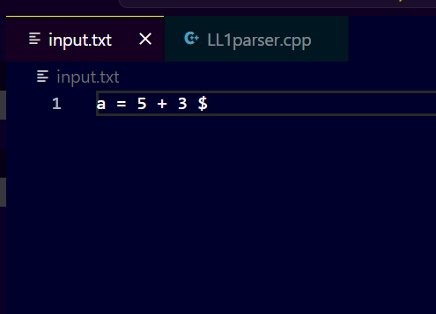

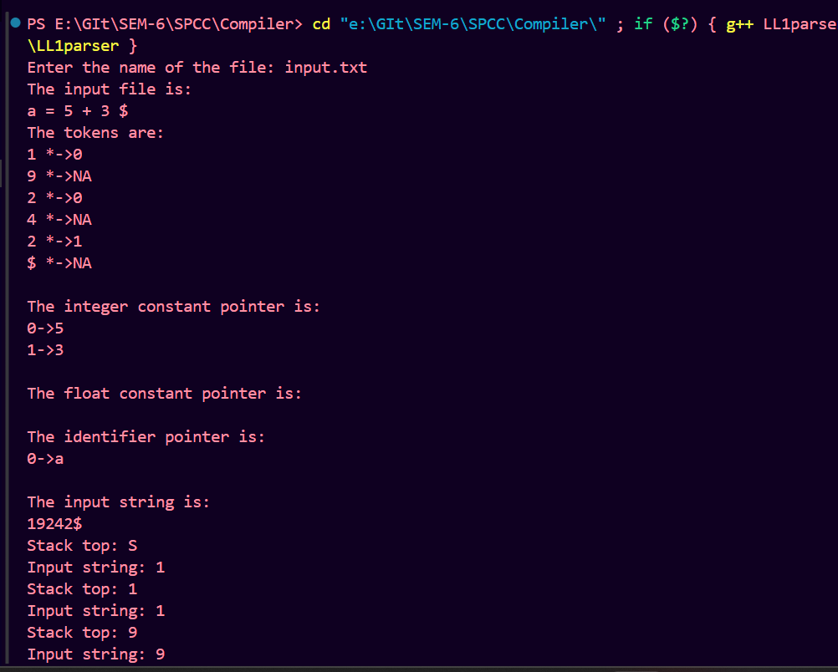

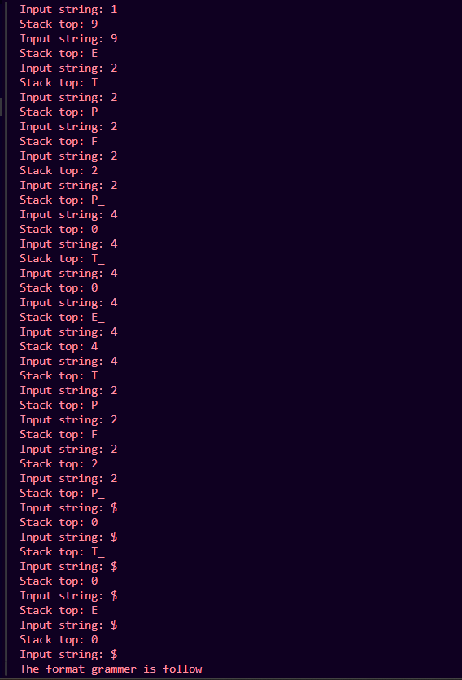

Not Accepted=>

